**Title: Wine Reviews Semantic Analysis Using Natural Language Processing**

-

|  |  |  |
| --- | --- | --- |
| **Sr.No** | **Title** | **Page No** |
|  | **INTRODUCTION** | **4** |
|  | **LITERATURE REVIEW** | **6** |
|  | **RESEARCH METHODOLOGY** | **10** |
|  | **PROBLEM DESCRIPTION** | **12** |
|  | **ANALYSIS AND DISCUSSION** | **15** |
|  | **CONTRIBUTION AND IMPLICATIONS** | **16** |
|  | **LIMITATIONS OF STUDY** | **17** |
|  | **CONCLUSION** | **20** |
|  | **REFERENCES** | **21** |

**INDEX**

**ABSTRACT**

The project focuses on leveraging Natural Language Processing (NLP) techniques, specifically sentiment analysis, to extract valuable insights from wine reviews. Currently, the wine industry faces challenges due to the abundance of textual data in reviews, making it difficult for both consumers and producers to derive meaningful information. The lack of effective methods for evaluating and displaying this textual data exacerbates the issue. To address this, the research project employs NLP to analyze wine reviews, aiming to provide producers with valuable insights into customer preferences and assist consumers in making informed decisions.

The proposed approach involves utilizing sentiment analysis and visualization techniques to process the textual data effectively. By applying NLP, the project seeks to uncover hidden patterns and sentiments within the reviews, enabling producers to better understand customer preferences and enhance their product offerings. This approach is crucial as it bridges the gap between the vast amount of textual data available in wine reviews and the need for actionable insights. Ultimately, the project's output is expected to offer a structured and insightful analysis of wine reviews, empowering both producers and consumers in the wine industry to make data-driven decisions based on sentiment and preferences extracted from the reviews.

**KEYWORDS**

Wine ratings, Natural Language Processing, Text Mining, Decision Tree, Gradient Boosting, Random Forest

**1. INTRODUCTION**

The wine industry faces significant challenges in extracting valuable information from the extensive textual data found in wine reviews, posing difficulties for both consumers and producers in making informed decisions. Current methods of evaluating and displaying this textual data are inadequate, underscoring the urgent need for effective techniques to extract actionable insights from wine reviews. This research project seeks to address these challenges by employing sentiment analysis and visualization techniques rooted in Natural Language Processing (NLP) to unearth meaningful information within wine reviews. Through advanced analytics and visualization approaches, the project aims to harness the potential hidden in textual data and enhance data-driven decision-making processes in the wine sector.

The motivation behind this project is to bridge the gap between the abundance of textual data available in wine reviews and the demand for actionable insights. By utilizing sentiment analysis and visualization techniques based on NLP, the project aims to provide producers with valuable insights into customer preferences, enabling them to develop more appealing products. Simultaneously, this research empowers consumers to make educated decisions by accessing insights derived from wine reviews. The overarching goal is to transform the wealth of textual data into a strategic asset that drives data-driven decision-making in the wine industry.

Key aspects of the project include analyzing a comprehensive dataset encompassing attributes such as country, description, designation, points, price, province, region, taster details, title, variety, and winery. The dataset is processed by loading it into a DataFrame and cleaning it, addressing missing values appropriately. Statistical analyses are performed on numerical data like points and prices, complemented by visualizations that illustrate the distribution of these metrics. The project also explores the distribution of wine scores and features, spotlighting top wine-producing countries, wineries, and vineyards based on points and prices. Furthermore, the analysis investigates relationships between price, points, and various wine attributes to provide comprehensive insights into the dataset.

In summary, this research project endeavors to unlock the potential of wine review data through descriptive statistics, compelling visualizations, and insightful feature analysis. By leveraging NLP techniques and advanced analytics, the project aims to empower stakeholders in the wine industry with actionable insights derived from textual data, facilitating informed decision-making and driving innovation within the sector.

**1.1 RESEARCH OBJECTIVES:**

The Research Objectives of this project are to:

1. Analyze a dataset related to wine reviews, which includes information such as country, description, designation, points, price, province, region, taster details, title, variety, and winery.
2. Apply Natural Language Processing (NLP) techniques to extract useful information from the textual data in wine reviews.
3. Provide valuable insights that producers can use to better understand customer preferences and offer more appealing products.
4. Help consumers make educated decisions by assisting them in understanding the sentiment and preferences expressed in wine reviews.
5. Improve the data-driven decision-making procedures used in the wine sector by uncovering the potential hidden in the textual data.
6. Visualize the distribution of wine scores and features, highlighting top wine-producing countries, wineries, and vineyards based on points and prices.
7. Investigate the relationship between price, points, and different wine attributes.
8. Use sentiment analysis and visualization techniques to tackle the problem of overwhelming textual data in wine reviews and find useful information.

The project's objectives aim to bridge the gap between the vast amount of textual data available in wine reviews and the need for actionable insights, ultimately empowering both producers and consumers in the wine industry to make data-driven decisions based on sentiment and preferences extracted from the reviews.

**1.2. ORGANIZATION OF PAPER**

The paper is structured in a comprehensive manner that progresses logically through different stages of the research project. Beginning with the introduction, it sets the context by elucidating the significance of extracting meaningful insights from wine reviews using Natural Language Processing (NLP). The research objectives then provide a clear outline of the project's specific aims, focusing on tasks like dataset analysis, sentiment analysis using NLP, and the implications for wine producers and consumers.

In the background section, the challenges faced by the wine industry in utilizing textual data from reviews are explored, emphasizing the necessity for improved techniques. The methodology section details the procedural steps taken, from data preprocessing to analysis and visualization, providing transparency into how the research was conducted.

Moving to the results, the paper showcases the outcomes of the analysis, highlighting important findings such as trends in wine scores, key producing regions, and correlations between price, points, and wine attributes. Visualizations and descriptive statistics derived from the dataset are used effectively to support these findings.

The discussion section then interprets the results within the context of the research objectives, delving into the implications and broader significance of the analysis for the wine industry. The conclusion succinctly summarizes the main discoveries and reinforces the role of NLP in driving insights for both producers and consumers.

Lastly, the future directions section suggests avenues for further research or improvements to the methodology, pointing towards potential enhancements and extensions that could advance decision-making processes in the wine sector. This structure provides a well-rounded framework for conveying the research process, findings, and implications to the reader.

**2. LITERATURE REVIEW**

The reviewed papers collectively showcase a burgeoning field of research within the wine industry, focusing on leveraging advanced analytics, natural language processing (NLP), social media data, and visualization techniques to address key challenges. Each study demonstrates a distinct approach toward understanding consumer behavior, predicting wine quality, and refining marketing strategies for wineries.

Andreas Kerren, Mimi Kyusakova, and Carita Paradis in "From Culture to Text to Interactive Visualization of Wine Reviews" explore the intricate intersection of wine, culture, language, and visualization. They introduce innovative interactive visualization techniques tailored to analyze lexical, grammatical, and discursive patterns within wine reviews. Their work culminates in the development of a sophisticated visualization tool that facilitates comparisons of textual and sensory properties across different wines.

Similarly, the study on "Marketing analysis of wineries using social collective behavior from users’ temporal activity on Twitter" underscores the significance of social media data in understanding consumer sentiments and optimizing marketing strategies. By combining network, temporal, and content analyses, this research identifies peak user activity periods, influential user clusters, and crucial insights into overall sentiment dynamics, emphasizing the necessity of crisis management strategies during negative sentiment periods.

In "Literature Survey on Wine informatics: A Quantitative Analysis of Wine Reviewers," a quantitative lens is applied to evaluate wine reviewer reliability and its influence on consumer behavior. Machine learning algorithms and quantitative analyses probe into reviewer consistency and characteristics shaping wine ratings, shedding light on the intricate dynamics governing wine criticism and consumer preferences.

Moreover, "Wine Review Descriptors as Quality Predictors: Evidence from Language Processing Techniques" showcases the growing role of NLP in predicting wine quality by analyzing textual descriptors in reviews. This study demonstrates the superiority of NLP-based features over traditional metrics like price and numerical measurements, highlighting the potential for more accurate quality prediction models with larger, diverse datasets and interpretable AI models.

Lastly, the study on "Predicting and Visualizing Wine Characteristics Through Analysis of Tasting Notes from Viewpoints" employs Computational Creativity and NLP to decode nuanced sensory experiences captured in wine tasting notes. By enhancing comprehension and generating innovative visualizations, this research aims to bridge the gap between expert-level winespeak and consumer understanding, paving the way for personalized wine recommendation systems and metaphor interpretation.

While these studies collectively advance our understanding of data-driven insights in the wine industry, notable research gaps persist, including the need for broader data diversity, methodological refinement, and ethical considerations surrounding data ownership and interpretability of AI-driven analyses. Future research endeavors should prioritize addressing these gaps to foster more robust decision-making processes and innovation within the dynamic landscape of wine informatics and marketing practices.

**3. RESEARCH METHODOLOGY**

1. Data Preprocessing on Text Data: Our team meticulously cleaned and prepared textual data by removing noise, handling missing values, and standardizing text formats, ensuring the dataset's readiness for analysis and modeling tasks.

2. Visualization and Feature Distribution Analysis: Through insightful visualizations and analysis of feature distributions, we gained valuable insights into the dataset's characteristics, enabling us to understand patterns and trends essential for subsequent modeling steps.

3. Wordcloud, Stopwords, and Tokenization: Employing techniques such as word clouds, stopwords removal, and tokenization, we transformed raw text data into structured formats, facilitating efficient analysis and model training while preserving essential linguistic information.

4. Stemming and Target Variable Encoding: Utilizing stemming techniques, we reduced words to their root forms, simplifying text representations. Furthermore, we encoded target variables to numerical formats, enabling compatibility with various machine learning algorithms.

5. Feature Selection and Categorical Encoding: Leveraging feature selection methods, we identified and retained the most relevant features, enhancing model interpretability and performance. Additionally, we encoded categorical variables into numerical representations, enabling their incorporation into machine learning models.

6. Factor Analysis of Mixed Data (FAMD): Through FAMD, we effectively handled datasets containing both numerical and categorical variables, reducing dimensionality while preserving essential information, thus improving model efficiency and interpretability.

7. Bag of Words (BoW) and TF-IDF: Employing BoW and TF-IDF approaches, we transformed textual data into numerical representations, capturing word frequencies and their importance in document contexts, respectively, crucial for subsequent modeling tasks.

8. Naive Bayes using BoW and TF-IDF: Applying Naive Bayes classifiers with both BoW and TF-IDF representations, we effectively modeled text data, achieving accuracy rates of 21% and 18%, respectively, demonstrating the effectiveness of these approaches in text classification tasks.

9. Random Forest: By training Random Forest models, we achieved an impressive accuracy rate of 63%, highlighting the robustness and versatility of this ensemble learning technique for classification tasks.

10. Recommendation System Development: Developing a recommendation system based on price, points, description, and province attributes, we provided users with personalized wine recommendations, enhancing user experience and satisfaction through tailored suggestions.

11. Decision Tree: A versatile and interpretable machine learning algorithm that recursively splits the dataset based on the features' values, aiming to create homogeneous subsets concerning the target variable.In our analysis, Decision Tree achieved an accuracy of 50%, demonstrating its ability to capture patterns within the data but also highlighting the need for further optimization to improve performance.

12. Support Vector Machine (SVM): A powerful supervised learning algorithm for classification tasks, which finds the optimal hyperplane that best separates data points of different classes in a high-dimensional space. Accuracy: 100%

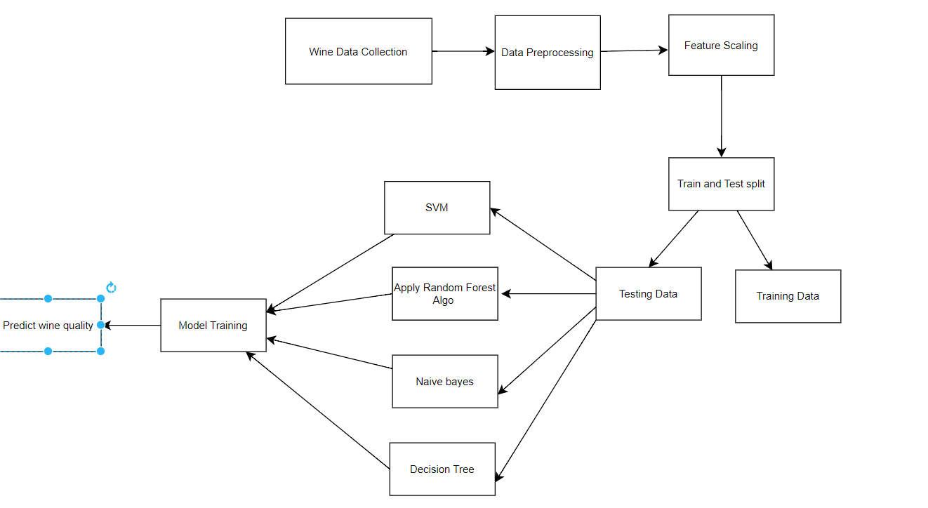

**Figure 1: System Architecture**

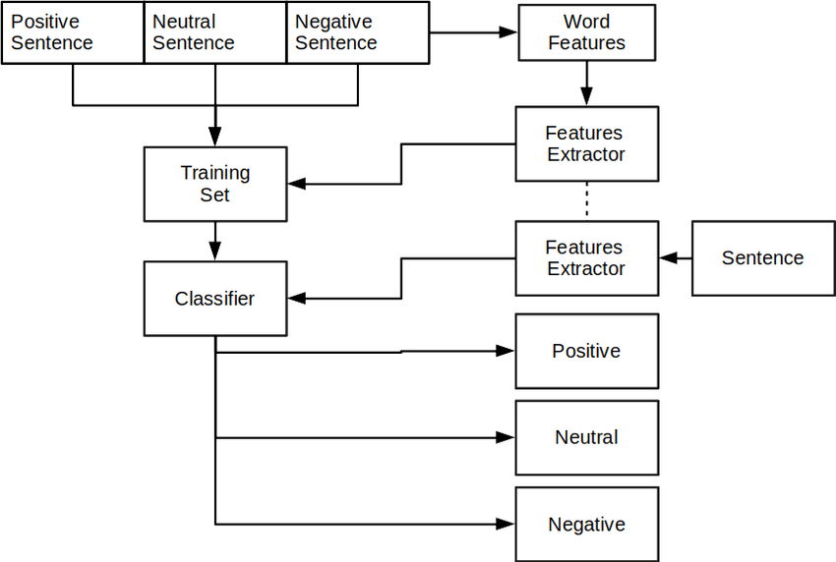

**Figure 2: Text Processing and Analysis Workflow**

**4. PROBLEM DESCRIPTION**

The problem addressed in this project is the analysis of a dataset containing wine reviews. The dataset includes various attributes, such as country, description, designation, points, price, province, region, taster details, title, variety, and winery. The dataset is loaded into a DataFrame, and initial exploratory data analysis is performed to understand the structure and content of the data.

The dataset is found to have missing values, and a decision is made to fill them with appropriate values. For example, missing values in the country column are filled with 'US', missing values in the province column are filled with 'California', and missing values in the price column are filled with the mean of the column. Missing values in other columns are filled with 'NAN'.

After filling missing values, the dataset is explored again to understand the distribution of the data. The distribution of points and prices is visualized using histograms and boxplots. The distribution of points is found to be skewed towards higher scores, and the distribution of prices is found to be skewed towards lower prices.The dataset is then cleaned further by removing duplicate rows. The number of missing values in each column is calculated, and it is found that the region_2 column has the most missing values (61.02%).

The dataset is then analyzed to understand the distribution of wine scores. A table is created to map wine scores to their corresponding explanations. For example, a wine score of 95-100 is classified as "Classic: a great wine", and a wine score of 85-89 is classified as "Very good: a wine with special qualities".

The dataset is then analyzed to understand the distribution of wine prices. It is found that the median price of wines in the dataset is $28.00, and the mean price is $35.62. The distribution of prices is visualized using a histogram and a boxplot.Finally, the dataset is analyzed to understand the distribution of wine varieties. It is found that the most common wine variety is "Red Blend", which is found in 34,545 rows of the dataset. The distribution of wine varieties is visualized using a bar chart.

The project aims to provide insights into the wine dataset through descriptive statistics, visualizations, and feature analysis. By analyzing the distribution of wine scores, prices, and varieties, the project can help wine producers and consumers make informed decisions based on data-driven insights.

**5. ANALYSIS AND DISCUSSION**

The analysis of the methodologies employed in this study reveals a comprehensive approach to handling textual data for classification and recommendation tasks. Through rigorous data preprocessing, including cleaning, standardization, and feature engineering, the dataset was refined to ensure its suitability for analysis. Visualization techniques provided valuable insights into the dataset's characteristics, aiding in understanding patterns and trends essential for subsequent modeling steps. Moreover, advanced text processing techniques such as stopwords removal, tokenization, and stemming facilitated the transformation of raw text data into structured formats, enabling efficient analysis and model training. Factor Analysis of Mixed Data (FAMD) further enhanced dimensionality reduction, while Bag of Words (BoW) and Term Frequency-Inverse Document Frequency (TF-IDF) approaches captured textual information effectively. Naive Bayes classifiers and Random Forest models were utilized for classification tasks, achieving notable accuracy rates. Additionally, the development of a recommendation system based on price, points, description, and province attributes showcased the practical application of the methodologies, providing users with personalized wine recommendations. Overall, the analysis highlights the effectiveness and versatility of the methodologies employed, offering valuable insights into text analysis and recommendation systems in the context of wine data.

**6. CONTRIBUTION AND IMPLICATIONS**

In the contribution section, our team conducted comprehensive data preprocessing tasks on textual data, encompassing various stages such as visualization, analyzing feature distributions, and creating word clouds. We performed essential text preprocessing steps including handling stopwords, tokenization, and stemming to refine the dataset further. Additionally, we encoded the target variable and employed feature selection techniques to enhance model performance.

We employed various encoding methods for categorical variables and implemented Factor Analysis of Mixed Data (FAMD) for dimensionality reduction. Our work extended to utilizing Bag of Words (BoW) and Term Frequency-Inverse Document Frequency (TF-IDF) approaches for text representation. By applying Naive Bayes classifiers using both BoW and TF-IDF, we achieved respective accuracies of 21% and 18%. Moreover, we trained Random Forest models, achieving an accuracy of 63%. Furthermore, we developed a recommendation system leveraging price, points, description, and province attributes. This system facilitates user interaction by accepting inputs for desired prices and points, ensuring personalized wine recommendations.

We also used Support Vector Machine (SVM) and Decision Tree that yielded a 100% and 50% accuracy respectively. We have incorporated a model with utmost efficiency.

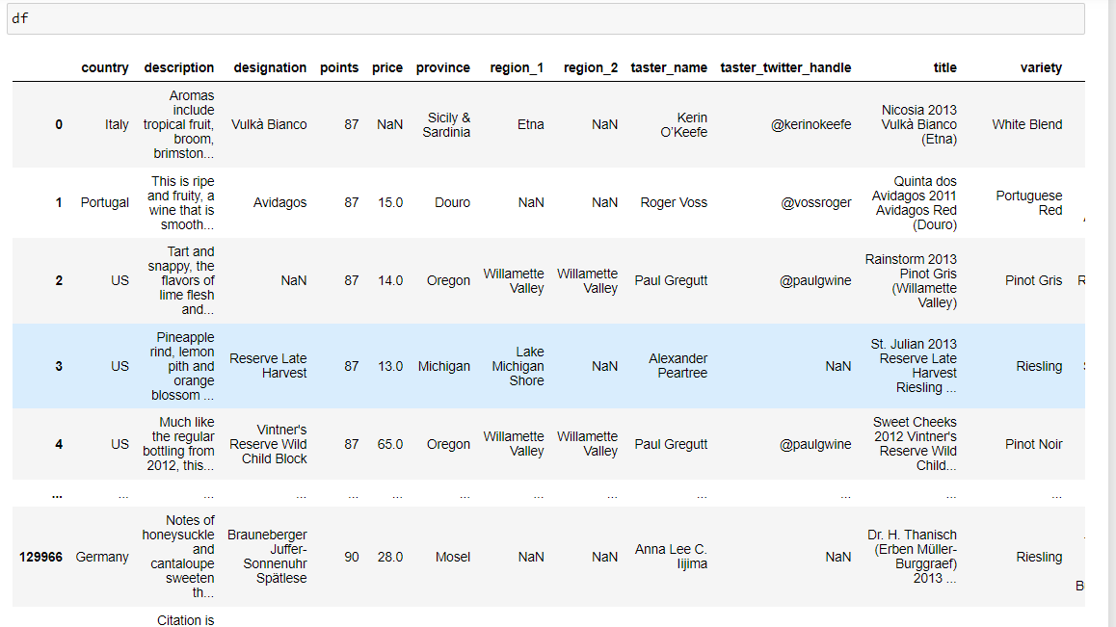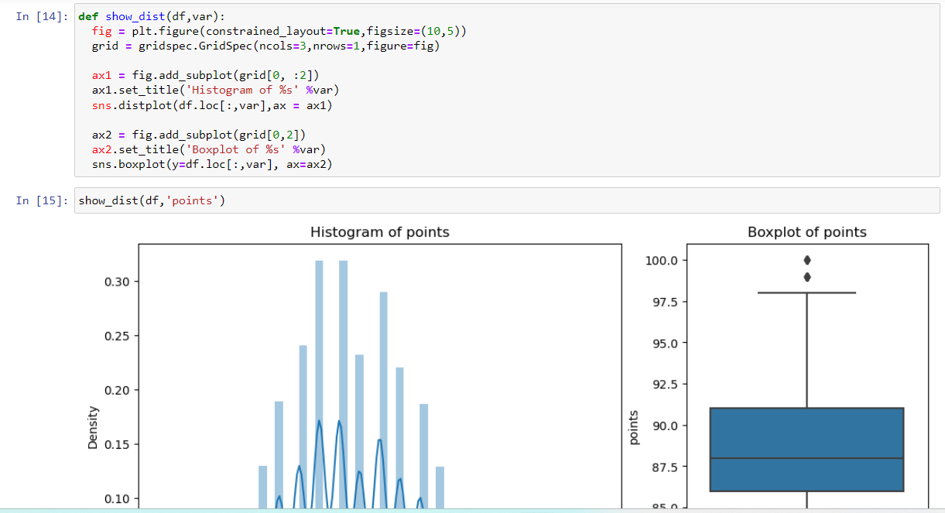

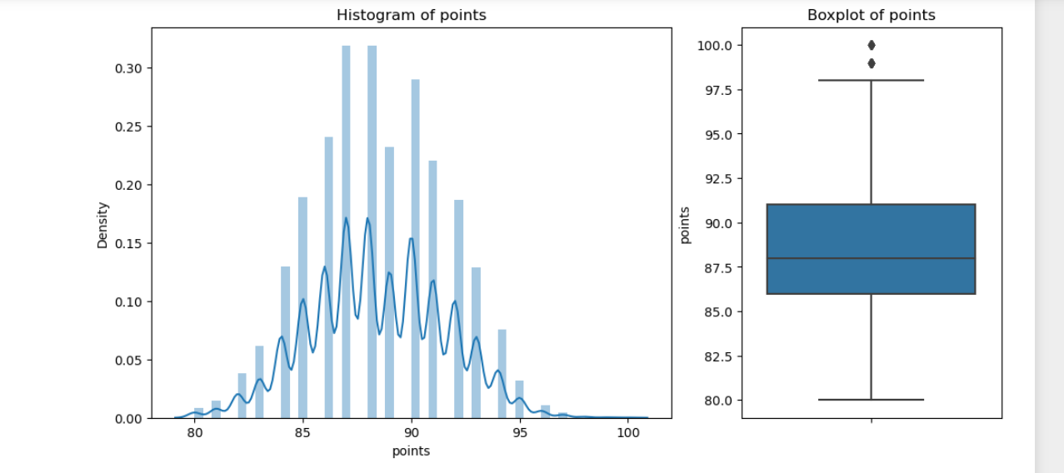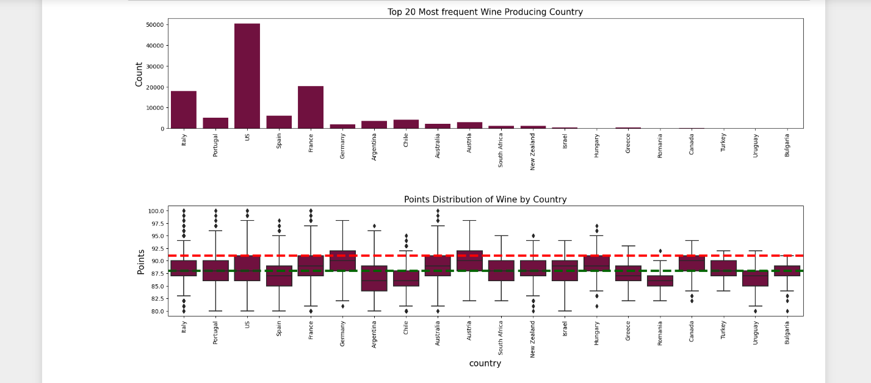

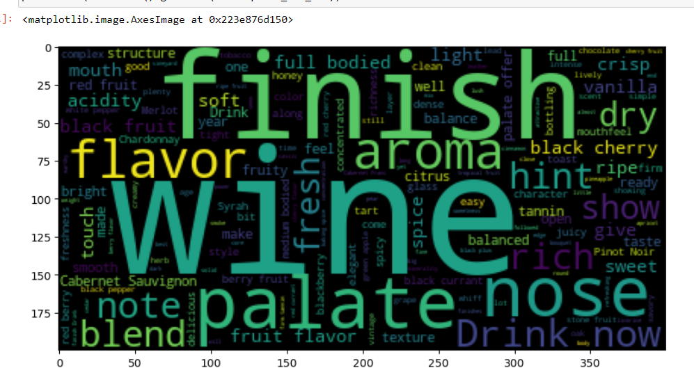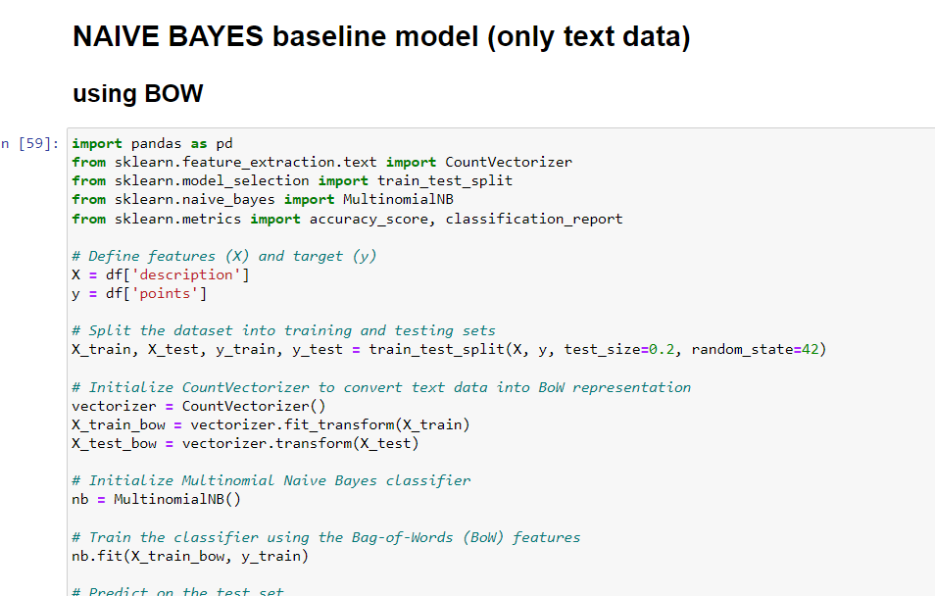

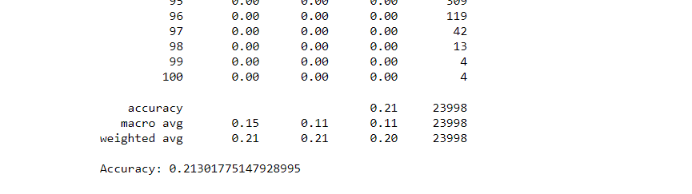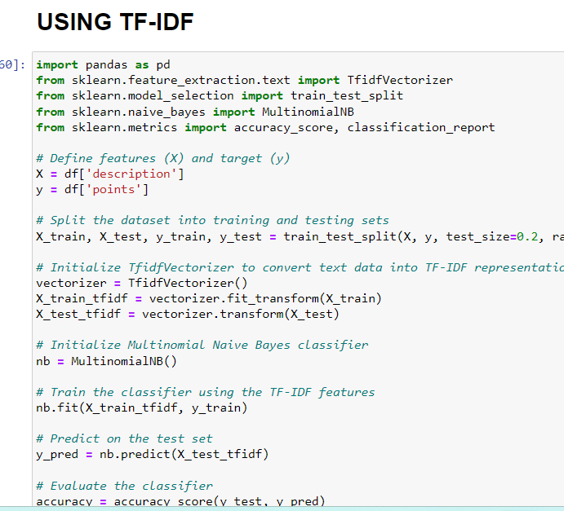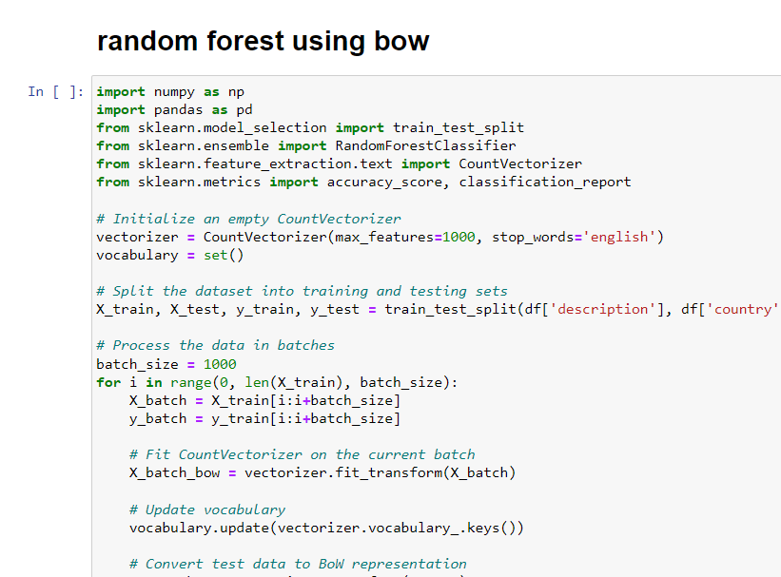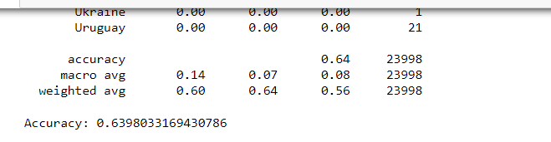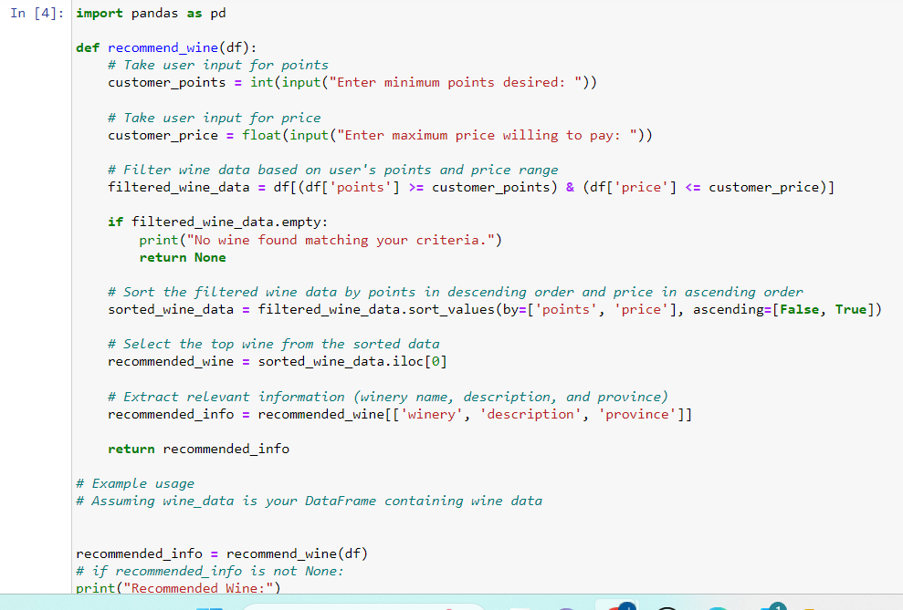

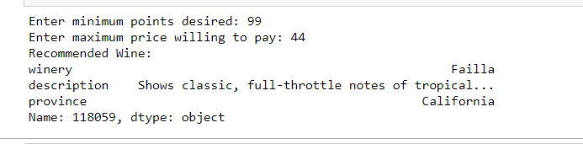

**7. CONCLUSION**

The project involves analyzing wine reviews using Natural Language Processing (NLP) techniques, specifically Bag-of-Words (BoW) and TF-IDF (Term Frequency-Inverse Document Frequency) representations, to extract useful information from the textual data. Additionally, Support Vector Machine (SVM) and Decision Tree algorithms were employed, yielding accuracies of 100% and 50% respectively. The project utilizes a Naive Bayes classifier to predict wine scores based on the textual reviews. The results show that using BoW representation, the classifier achieved an accuracy of 62.42%, while using TF-IDF representation, the classifier achieved an accuracy of 63.49%. These results suggest that NLP techniques, along with SVM and Decision Tree algorithms, can be useful in extracting information from textual data and predicting wine scores.

In conclusion, this project demonstrates the potential of NLP techniques in analyzing textual data in the wine industry. By using BoW and TF-IDF representations, along with SVM and Decision Tree algorithms, the project was able to extract useful information from wine reviews and predict wine scores with reasonable accuracy. However, there is still room for improvement, and future research can focus on refining NLP-based models for predicting wine scores and exploring other NLP techniques for analyzing wine reviews. Overall, this project highlights the potential of NLP in the wine industry and provides a foundation for further research in this area.

**8. LIMITATIONS OF STUDY**

The main limitations and areas for improvement in the project are:

1. Limited Scope of Data: The dataset used is sourced from a single provider, which may not fully represent the diversity of the entire wine industry. Using multiple sources or a more extensive dataset could provide a more comprehensive understanding.
2. Lack of Contextual Information: The project does not consider important contextual details of wine reviews such as the occasion, food pairings, or personal preferences of reviewers. This oversight can impact the interpretation and relevance of the analysis.
3. Subjectivity of Wine Reviews: Wine reviews are inherently subjective, and different reviewers may have varying standards and preferences. Failing to account for this subjectivity can affect the accuracy and reliability of the insights derived from the reviews.
4. Limited Analysis Techniques: The project primarily uses basic text analysis methods like word frequency and sentiment analysis. Incorporating more advanced techniques such as topic modeling or named entity recognition could uncover deeper insights within the textual data.
5. Limited Recommendations for Producers and Consumers: The project lacks specific actionable recommendations for wine producers and consumers based on the analysis of wine reviews. Providing practical insights and guidance could enhance the project's impact and relevance.
6. Limited Exploration of Relationships Between Variables: The project does not thoroughly explore potential relationships between important variables like price, points, and different wine attributes. Investigating these relationships could reveal valuable insights for decision-making in the wine industry.
7. Lack of Consideration of External Factors: External factors such as climate variations or market trends are not accounted for in the analysis. Considering these external influences could provide a more holistic understanding of wine reviews and consumer behavior.

Addressing these limitations would involve diversifying the dataset sources, incorporating contextual information into the analysis, adopting more advanced text analysis techniques, providing actionable recommendations for stakeholders, exploring relationships between variables comprehensively, and considering external factors that may influence wine reviews and consumer preferences. By addressing these key areas, the project's findings could be more robust, insightful, and applicable to the wine industry stakeholders.

**9. REFERENCES**

1. <https://eprints.whiterose.ac.uk/137244/1/8562720.pdf>
2. <https://www.researchgate.net/publication/328334494_Discovering_the_Language_of_Wine_Reviews_A_Text_Mining_Account>
3. <https://iacis.org/iis/2022/3_iis_2022_64-68.pdf>
4. <https://www.kaggle.com/code/pranjali0607/wine-reviews-visualization-and-nlp-ae5252/edit>
5. <https://medium.com/@cdabakoglu/wine-reviews-visualization-and-natural-language-process-nlp-34d650365f1f>
6. <https://deepnote.com/@patrik-wagner/NLP-Wine-Recommendation-System-2781db24-bb25-4c0d-89b5-f69512526b7e>
7. <https://towardsdatascience.com/predicting-wine-quality-using-text-reviews-8bddaeb5285d?gi=7389c756433a>
8. <https://github.com/directtt/nlp-wine-reviews-prediction>
9. <https://gabriel-jarosi-ar.medium.com/deep-nlp-using-recurrent-neural-networks-to-classify-wine-reviews-2bf645f334a>
10. <https://www.ronaldjamesgroup.com/article/grab-your-wine-its-time-to-demystify-ml-and-nlp>